**HALF ADDER**

**EXP.NO: 21**

**AIM:**To design and implement the two bit half adder using Logisim simulator.

**PROCEDURE:**  
1)      Pick and place the necessary gates.  
2)      Insert 2 inputs into the canvas.  
3)      Connect the inputs to the XOR gate and AND gate.  
4)      Insert 2 outputs into the canvas.  
5)      Make the connections using the connecting wires.  
6)      Verify the truth table.   
  
**TRUTH TABLE:**

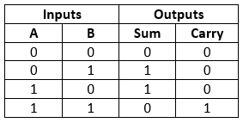  
  
  
  
  
  
  
  
  
  
S = A XOR B        C = A AND B  
**OUTPUT**  
  
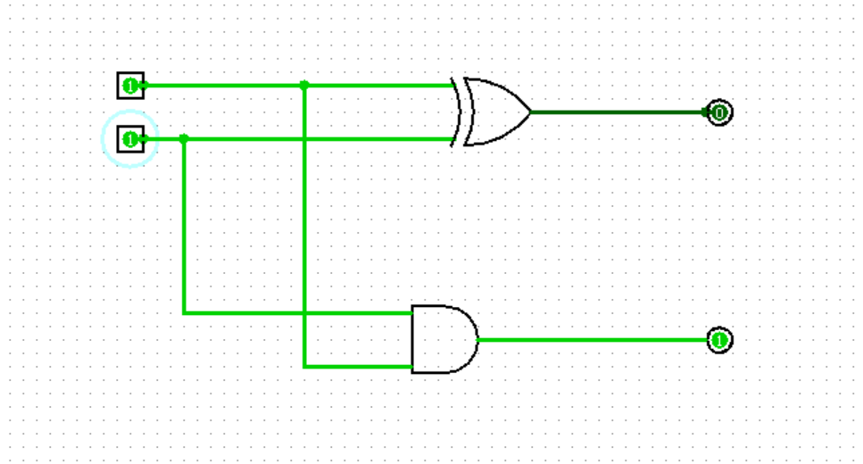  
  
  
  
  
  
  
  
  
  
  
  
  
  
  
**RESULT:**Thus 2-bit half adder has been designed and implemented successfully using logisim simulator.